Questions about likelihoods (P(H|D)) to show after testing

Questions will be asked about all nodes in the probability model except for dispersion, which is difficult to portray or describe accurately.

(1-7)

When a sector contains the building pictured, what is the probability of each facility type?

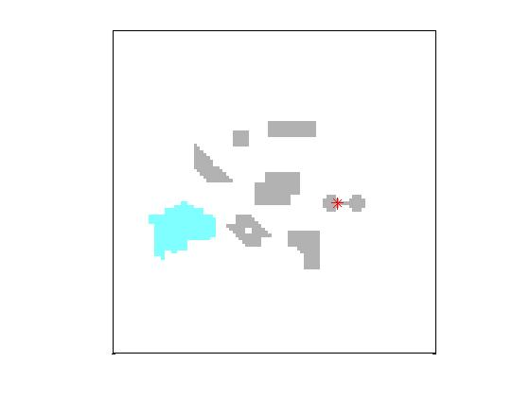

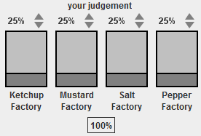

Answers:

Bldg1 = true likelihoods 0.35 0.12 0.35 0.19

Bldg2 = true likelihoods 0.30 0.10 0.30 0.30

Bldg3 = true likelihoods 0.36 0.12 0.16 0.36

Bldg4 = true likelihoods 0.33 0.33 0.15 0.19

Bldg5 = true likelihoods 0.08 0.37 0.17 0.38

Bldg6 = true likelihoods 0.07 0.31 0.31 0.31

Bldg7 = true likelihoods 0.08 0.36 0.36 0.20

(8)

When a sector contains water, what is the probability of each facility type?

Terrain = Water likelihoods 0.06 0.19 0.31 0.44

(9)

When any building in a sector contains the hardware pictured, what is the probability of each facility type?

BldgHdwr = one or more likelihoods 0.20 0.23 0.27 0.30

(10)

When a sector contains SIGINT, what is the probability of each facility type?

(picture of SIGINT dots)

SIGINTDensity = High or Low 0.40 0.10 0.40 0.10

(11)

When a sector contains MASINT1, what is the probability of each facility type?

(picture of MASINT1 dots)

MASINT1Density = High or Low 0.10 0.40 0.10 0.40

(12)

When a sector contains MASINT2, what is the probability of each facility type?

(picture of MASINT2 dots)

MASINT2Density = High or Low 0.10 0.40 0.40 0.10

Questions about joint probabilities P(D1,D2) to show after testing.

Questions will be asked about correlations between:

Buildings and buildings

Buildings and terrain

Buildings and building features (i.e. hardware)

Buildings and present INTs

Terrain and present INTs

Present INTs

Absent INTs

Only a subset of possible questions will be asked, to save time and prevent subject fatigue.

While joint probabilities for most of these will be clustered around 0.25, I have tried to choose questions with answers ranging from 0.1 to 0.5. I propose that sliders should be initialized to 50% (“indifferent”) rather than 0.25, to give us room to measure whether the subjects are

“Note: for these questions, your probabilities will not sum to 100%” should be displayed in the GUI.

Sliders should be initialized to 50%, not 25%.

After each question are listed the correct probabilities and the facility types the features are primarily associated with.

1. In all the sectors you have seen, how often did you see:

Buildings 1 and 2 together? 0.54 – A and C

Buildings 4 and 7 together? 0.4 - B

Buildings 3 and 5 together? 0.35 - D

Buildings 3 and 7 together? 0.31 – all DCBA

Buildings 1 and 5 together? 0.31 – all DCBA

Building 6 and water? 0.34, D

Building 7 and water? 0.27, BCD

Building 2 with hardware? 0.57 C

Building 7 with hardware? 0.48 DCB

1. In all the sectors you have seen, how often did you see:

Any MASINT1 and any MASINT2? 0.25 A

Any SIGINT and any MASINT1? 0.34 AC

Any SIGINT and any MASINT2? 0.25 A

No MASINT1 and no MASINT2? 0.25 C

No SIGINT and no MASINT1? 0.34 D

No SIGINT and no MASINT2? 0.25 C

1. In all the sectors you have seen, how often did you see:

Bldg1 and any MASINT2? 0.31 C

Bldg1 and any SIGINT? 0.4 AC

Bldg5 and any MASINT2? 0.32 B

Bldg5 and any SIGINT? 0.21 C

Water and any MASINT2? 0.2 CB

Water and any SIGINT? 0.17 C